**Worksheet 7: Setting Targets**

Many college health professionals struggle with setting achievable, realistic targets for outcome, performance, and process objectives. The tips below focus primarily on setting targets for health outcomes and performance.

**Using Peer Communities**

You can set targets by comparing your campus with others like it. Year in college, age, major, co-curricular activity, place of residence, race/ethnicity, and population size may define peer communities. The following may be used to describe one’s peers: typical values for a specific objective, means or medians, or the variation among peers.

Comparable data for campuses like yours may be found using the American College Health Association’s National College Health Assessment (ACHA-NCHA) (see [www.acha.org/ncha](http://www.acha.org/ncha)). Reference Group Reports posted at [www.acha.org/ncha/data-results/survey-results/](http://www.acha.org/ncha/data-results/survey-results/) will help you get started.

**Setting Targets**

Whenever possible, objectives should use current best scientific evidence and SMART (specific, measurable, achievable, realistic, and time-bound) targets (U.S. Department of Health and Human Services [HHS], 2009a). To set targets, planners should consider the current status (baseline), seek stakeholder input on the desired level of improvement, and assess what can realistically be accomplished based on the availability of financial resources and people’s time and energy in order to have a good balance between adaptability to your population/setting and fidelity to following prescribed protocols of evidence-based interventions (Veney & Kaluzny, 1998).

To help you and your stakeholders make a realistic assessment of what can be accomplished, determine: 1) priority audiences or segments of the campus population (the ones with unique needs for improved social and physical environments, or for whom there are special concerns); and 2) priority behaviors (determinants of health).

**Using Performance Measures**

Performance measurement responds to the need to ensure efficient and effective use of resources, particularly financial resources (U.S. Department of Health and Human Services Office of Disease Prevention and Health Promotion, 1997). It links the use of resources with health improvements and the accountability of individual partners. Performance measures can be incorporated within or based on your campus’ target health behaviors.

**Setting Performance Measures Step by Step**

Campuses can set Performance Measures by using the following steps and asking their campus Core Structure the following questions.

|  |  |
| --- | --- |
| **Step** | **Ask** |
| **1. Relate the performance measure to an important national, state, or local health priority area.** | What national, state, or local health priority will our plan address? |
| **2. Measure a result that can be achieved in five years or less.** | How will we measure our progress?  Can a change be measured in five years or less? |
| **3. Ensure that the result is meaningful  to a wide audience  of partners.** | Who are all the potential partners that have a stake in this health issue? |
| **4. Define the strategy that will be used to reach a result.** | What strategies will be effective for addressing this health issue?  What does your review of evidence-based literature tell you about interventions that 1) indicate the proportion in each priority audience may change behavior or health status and 2) balance fidelity and adaptation to your campus environment?  Do we have the fiscal and human resources to implement these strategies?  What do cost-benefit, cost-effectiveness, and cost-utility analysis of strategies tell you about best strategies to use for your population and priority audiences? |
| **5. Define the accountable entities.** | Who is responsible for implementing the different activities in each strategy? |
| **6. Draft measures  that meet statistical requirements for validity and reliability and have an existing source of data.** | What is our objective?  Is it specific, measurable, achievable, realist, and time-phased (SMART)?  Is there an existing data source for our measure? |

**Sample Organization Chart**

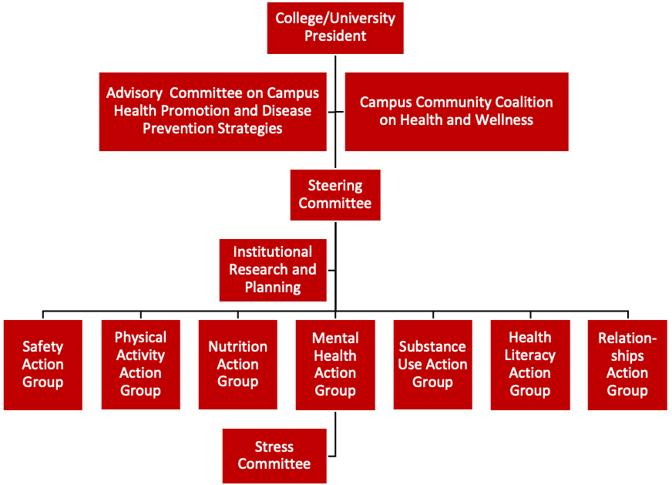

**Advisory Committee on Campus Health Promotion and Disease Prevention Strategies:** A public advisory committee involved in planning Healthy Campus. The six committee members are prominent campus and community experts in their fields, tapped to share their expertise in areas related to health promotion and disease prevention, including health policy, state and local public health, business, outcomes research, health economics, health communication, special populations, biostatistics, international health, health behaviors, environmental health, health systems, and epidemiology. These individuals serve in a variety of professional settings, including public, private, foundation, community-based, and academic organizations.

**Campus Community Coalition on Health and Wellness:** Key campus and local community stakeholders who develop and monitor a strategic plan. The intersectoral group applies a health-in-all-policies concept that includes students, faculty, and staff representing academic, housing, human resources, campus safety, and engineering departments, plus local business, city and county leaders.

**Steering Committee:** A committee with approximately 60 student, faculty, and staff members. It is charged with the prioritization and development of an action plan to address the leading health and wellness issues that affect academic performance and success.

**Institutional Research and Planning Office:** The office collects, aggregates, statistically analyzes, and reports data to support short- and long-range planning, budget and enrollment management, program review, and assessment. The office provides services to enable campus users to conduct their own data collection and statistical analysis and serves as the operational lead for the university in fiscal management, space management, and information technology support.

**Priority Action Groups:** Groups of 8–12 members (often Steering Committee members) charged with assessing, planning, implementing and tracking interventions for a single issue.

**References:**

American Psychological Association Practice Organization. (2010). *Psychologically healthy workplace program fact sheet: By the number*s. Retrieved from http://www.phwa.org/dl/2010phwp_fact_sheet.pdf. Accessed on June 25, 2012.

U.S. Department of Health and Human Services. (2009a). *Tenth meeting: March 26, 2009: Secretary’s Advisory Committee on   
National Health Promotion and Disease Prevention Objectives for 2020.* Retrieved from http://healthypeople.gov/2020/about/advisory/FACA10Minutes.aspx?page=3

# U.S. Department of Health and Human Services. (2009b). *Fifteenth meeting: September 17-18, 2009: Secretary’s Advisory Committee on National Health Promotion and Disease Prevention Objectives for 2020*. Retrieved from <http://healthypeople.gov/2020/about/advisory/FACA15Minutes.aspx>

## U.S. Department of Health and Human Services. (n.d.). *Healthy People 2020: Implementing Healthy People 2020 – MAP-IT: A guide to using Healthy People 2020 in your community*. Retrieved from <http://healthypeople.gov/2020/implementing/default.aspx>. Accessed on June 25, 2012.

U.S. Department of Health and Human Services Centers for Disease Control and Prevention. (n.d.). *Gateway to health communication & social marketing practice*. Retrieved from [http://www.cdc.gov/healthcommunication](http://www.cdc.gov/healthcommunication/). Accessed on June 25, 2012.

## U.S. Department of Health and Human Services Office of Disease Prevention and Health Promotion. (1997). *Winter 1997 prevention report: Improving the nation's health with performance measurement*. Retrieved from <http://odphp.osophs.dhhs.gov/pubs/prevrpt/archives/97winfoc.HTM>

Veney, James., A. Kaluzny. *Evaluation & Decision Making for Health Services*. Health Administration Press, Chicago. 1998. p 379-405.

**Adapted from material in the public domain:**U.S. Department of Health and Human Services, Office of Disease Prevention and Health Promotion. (n.d.). Healthy People 2020 Program Planning Tools. Retrieved June 2012, from http://www.healthypeople.gov.

**Original source:**  
Public Health Foundation, under contract with the Office of Disease Prevention and Health Promotion, Office of Public Health and Science, U.S. Department of Health and Human Services*.* (2002, February). *Healthy People 2010 Toolkit: A Field Guide to Health Planning* (pp. 93-98). Washington, DC: Public Health Foundation.

8455 Colesville Road, Suite 740

Silver Spring, MD 20910

(410) 859-1500

healthycampus@acha.org

www.acha.org/healthycampus

October 2022