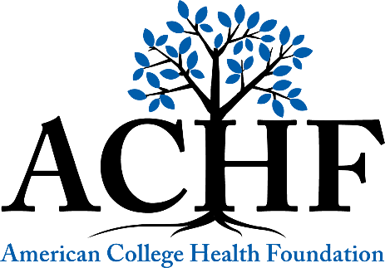

ACHF Legacy Society – Planned Gifts for the Future of College Health

Planned Gift Declaration of Intent

Name(s): Phone:

As an expression of my/our desire to help advance the future of college health and well-being, it is my/our intent to include the American College Health Foundation (ACHF) in my/our estate plans.

I/we have made the following provision for ACHF (Tax ID 52-1746232)
____ A gift in my/our will or trust
____ A gift of retirement plan assets
____ A gift of life insurance proceeds
____ Other gift provision (specify)

The current value of my/or gift is approximately $ .

I would like my/our gift to be:
____ Directed to ACHF’s strategic priorities (unrestricted)
____ Restricted to the following area I have discussed with the Foundation:
Notes:

In the future, should my/our specific restricted purpose no longer align with the Foundation’s strategic priorities, I/we authorize the ACHF Board of Directors to direct all monies received to the closest possible use.

Signature(s): Date:

____ ACHF has my/our permission to recognize this gift to help encourage others to consider similar gifts.
Name(s) as you wish to be listed:
____ I/we prefer to remain anonymous.

The Foundation recommends that all estate planning be done in consultation with a qualified tax attorney and/or financial advisor. Please attach relevant estate plan documentation to assist ACHF in honoring your intent.

Please send your completed form to the American College Health Foundation at achf@acha.org or 8455 Colesville Road, Suite 740, Silver Spring, MD 20910

